Study on the Effect of the Substrate Material Type and Thickness on the Performance of the Filtering Antenna Design

Mohammed K. Alkhafaji¹, Hana’a A. Alhamadani¹, Yasir I. A. Al-Yasir*², Ameer L. Saleh³, Raed A. Abd-Alhameed²

¹Electronic Techniques Department, Basra Technical Institute, Southern Technical University, Basra, 61006, Iraq
²Faculty of Engineering and Informatics, University of Bradford, Bradford, BD1 1JB, United Kingdom
³Department of Electrical Engineering, University of Misan, Misan, 62001, Iraq
*Corresponding author, e-mail: y.i.a.al-yasir@bradford.ac.uk

Abstract
This article presents a new design of a four-pole microstrip filtering antenna. The filtering antenna consists of a bandpass filter, which has four resonators integrated to a monopole patch antenna. The filtering antenna is designed with a relatively high bandwidth of about 1.22 GHz to satisfy a high-speed data transmission. Three types of dielectric substrate materials were used for the design of the filtering antenna, which is RT/Duroid 5880, RO3003, and FR-4. The simulation results of the filtering antenna design, which are established on the three different dielectric substrate materials, are done by using Computer Simulation Technology (CST) software. Comparison results of the filtering antenna that is established on the three different dielectric substrate materials are done at a fixed substrate height and different substrate heights. The filtering antenna is designed at a center frequency f0= 2.412 GHz, which is suitable for WLAN applications.

Keywords: Filtering antenna, bandpass filter; dielectric substrate material; RT/Duroid 5880; RO3003 FR-4; CST software.

1. Introduction
Ever-increasing demand for compact wireless communication transceivers continues to impact the field of microwave (MW) and radio frequency (RF) applications [1, 2]. Some of the most important modules in such systems are the microstrip antennas and filters [3-15], and its performance greatly effects the performance of the whole wireless communication systems.
In recent years, the microstrip filtering antenna has become one of the best-desired device structures because of their low profile, compact size, lightweight, and ease of fabrication. The microstrip filtering antenna is beneficial because it can be directly printed onto the dielectric substrate materials [16]. Filtering antenna design has many applications, mostly in modern wireless communication systems because of the filtering and radiating responses are occurring simultaneously [17].
It is known that the use of the substrate material in the design of RF/microwave circuits is a common and essential issue. One of the design basics is to choose the appropriate substrate material type as well as thickness to fit the proposed application. Finding the dielectric substrate for printed-circuit-board (PCB) materials provides a high-performance amount for acceptable charges at these frequencies represent a great challenge. By recognizing the key parameters and features of interest to PCB materials at high frequencies, such as how different types of PCB’s behave for different types of substrate materials at high frequencies (millimeter-wave frequencies). The selection can be carefully conceived when choosing printed circuit board materials for use in high frequencies [18].
This work presents three different types of dielectric substrate materials to be used in filtering antenna design and then check the design quality and its suitability for the application, which is designed for.

2. Properties of the Dielectric Substrates

  - FR-4 Glass Epoxy Dielectric Substrate
FR-4 is a low-cost PCB material, made from fiberglass textile implemented in epoxy resin. The “FR” in FR-4 indicates to “fire resistant”. It has mostly substituted the (flammable) board material G-10 because of this feature. The FR-4 material, usually works well, when designing below 1GHz. However, as frequencies rise beyond 1GHz, the passive circuit elements have to be taken into consideration. The main considerations for circuit design in the 3-6 GHz involve skin effect, surface roughness, proximity effect, and dielectric substrate [19]. The FR-4 dielectric constant ε_{r} has been reported between 4.3 – 4.8, and is slightly dependent on the frequency. The loss tangent tanδ of FR-4 is 0.018.

  - RT/Duroid 5880 Dielectric Substrate
Composites RT/Duroid 5880 microfiber reinforced PTFE is designed for demanding stripline and microstrip line applications. RT/Duroid is a glass microfiber reinforced PTFE (Poly Tetra Fluoro Ethylene) composite built by Roger Corporation. They show a very good chemical resistance, involving solvent and reagents utilized in printing and coating, ease of cutting and fabrication, shearing, machining, and environment-friendly [7]. RT/Duroid 5880 has a low loss tangent tanδ of about 0.004 and dielectric constant ε_{r} = 2.2 [20].

2.3. RO3003 Dielectric Substrate
Title RO3003 laminates is a ceramic-filled (Poly Tetra Fluoro Ethylene) PTFE composite circuit material with mechanical characteristics, which are uniform regardless of the choosing of the dielectric constant. This case permits the designers to develop multi-layer board designs, which are used differently dielectric constant materials for individual layers, without facing accuracy problems [21]. RO3003 has low loss tangent tanδ = 0.0013 and dielectric constant ε_{r} = 3.0.

3. Filtering Antenna Structure
The layout of the proposed filtering antenna structure is shown in Figure 1. The filtering antenna consists of four pole bandpass filter and monopole patch antenna. The integration of the BPF with monopole patch antenna is done by connecting the second port of the BPF with the antenna. A 50-Ω microstrip feed-line was fed both the BPF and monopole patch antenna, so there is no need to the additional matching circuit.
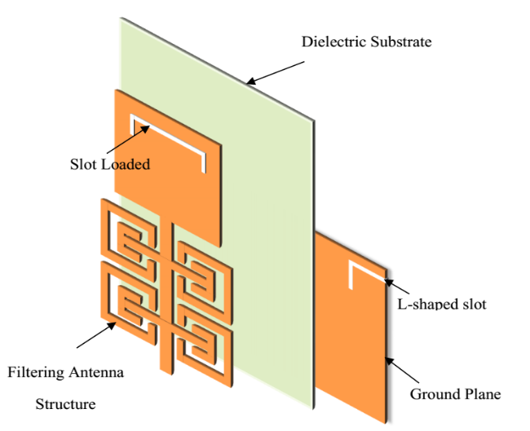
Figure 1. Filtering antenna structure layout

The four pole bandpass filter consists of four resonators, which are connected to the microstrip feed-line established on a dielectric substrate material with ground plane has an L-shaped slot etched as shown in Figure 2. Each resonator consists of the square open loop with a longitudinal strip ended with E-shaped arms.
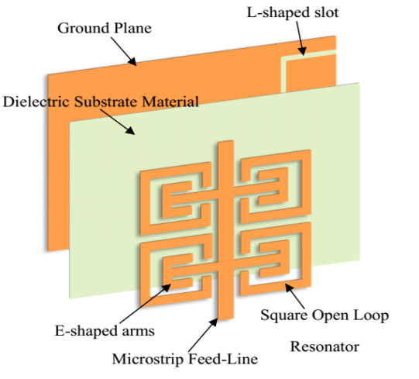
Figure 2. Four-pole bandpass filter structure layout

The filtering antenna was established on three different types of dielectric substrate materials, which are FR-4, RT/Duroid 5880, and RO3003. Firstly, these substrate materials are kept at a fixed thickness, and then the thickness of each dielectric substrate was changed to investigate, which of these three types are more suitable for the specifications for this application. The absorption of electrical energy by a dielectric material, which is exposed to an alternating electric field, is named dielectric loss. Dielectric loss is due to the influence of the limited loss tangent, tanδ in which the losses increasing and directly proportional to the operating frequency. Generally, the dielectric constant of the dielectric substrate ε_{r} is a complex number and is given by:

$ε_{r}=ε_{r}^{'}+jε_{r}^{"}$ (1)

Where,
$ε_{r}^{'}$ - Is a real part of the dielectric constant.
$ε_{r}^{"}$ – Is an imaginary part of the dielectric constant.

Then the loss tangent is given as [22]:

$tanδ=\frac{ε_{r}^{"} }{ε_{r}^{'}}$ (2)

The relationship between the tangent loss and dielectric loss is given by the following formula [23]:

$α_{d}=\frac{ε_{r}}{\sqrt{ε_{reff}}}∙\frac{ε_{reff}-1}{ε_{r}-1}∙\frac{π}{λ_{o}}∙tanδ_{d}$ (3)
Where,
$α_{d}$ – Is a dielectric loss.
$ε_{reff}$ – Is the effective dielectric constant of the substrate material.
$λ_{o}$ – Is a free space wavelength.

Figure 3, shows the dielectric loss for the three types of dielectric substrates, which are used in this research article. The microstrip propagation delay t_{pd} is a function of a substrate dielectric constant ε_{r}:

$t_{pd}\left({ns}/{ft}\right)=1.017\sqrt{{0.475ε}_{r}+0.67}$ (4)
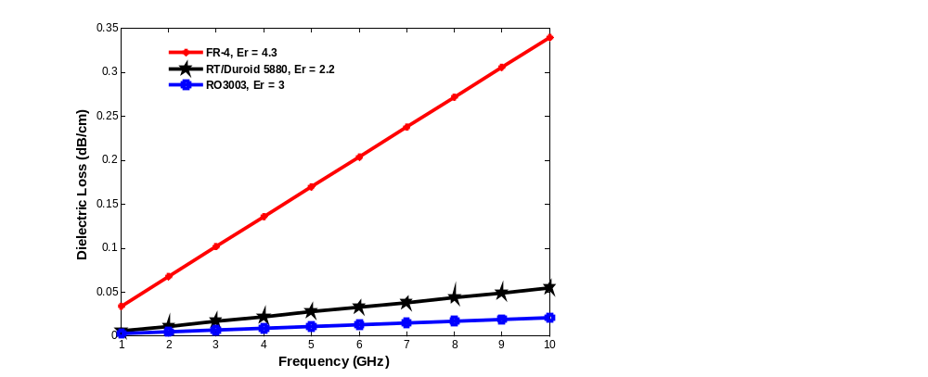
Figure 3. Dielectric loss versus frequency for different types of dielectric substrate materials

Attenuation sources of practical microstrip lines are due to the effects of radiation and finite conductivity of the conductor lines. In addition, energy in a microstrip is depending on the dielectric constant ε_{r}, substrate thickness h, and the circuit geometry. Using low dielectric constant substrate has a low concentration energy, which leads to a great radiation losses. Figure 4, shows the relationship of the propagation delay with respect to the dielectric constant of different types of dielectric substrate materials.

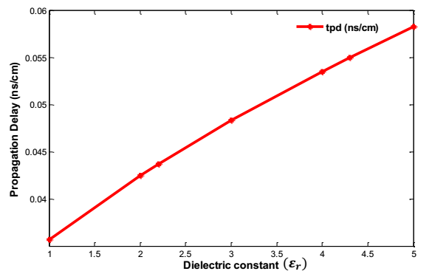
Figure 4. Propagation delay versus dielectric constant

4. Results and Discussion
Figure 5, shows the filtering antenna design structure with its optimized dimensions, and the optimized dimensions are stated in Table 1. Figure 6, shows the reflection parameter (S₁₁-parameter) and gain for the filtering antenna, which is designed on RT/Duroid 5880 dielectric substrate with height h = 30.944 mil and dielectric constant 2.2.
The filtering antenna has designed at a center frequency f_{o}= 2.412 GHz, and a band edges f₁= 1.872 GHz and f₂= 3.1099 GHz. The filtering antenna is suitable for WLAN applications and a relatively high bandwidth is fit the fast data transmission, which is required in a modern communication systems. Figure 7, shows the S₁₁-parameter of the filtering antenna without L-shaped Defected Ground Structure (DGS).
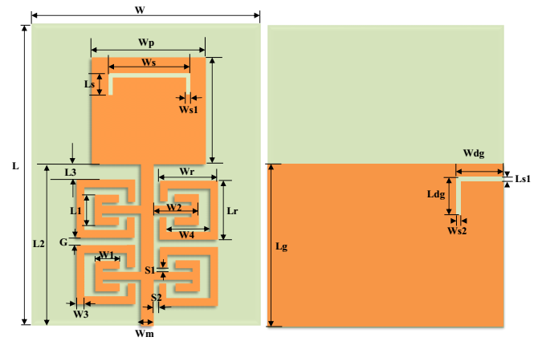
Figure 5. Filtering antenna Structure with its optimized dimensions

Table 1
The optimized dimension of the filtering antenna
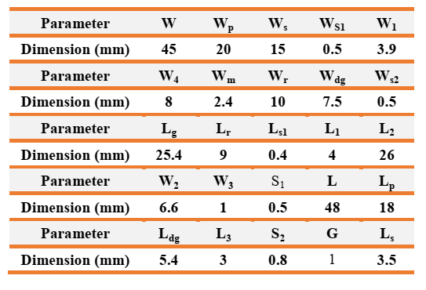

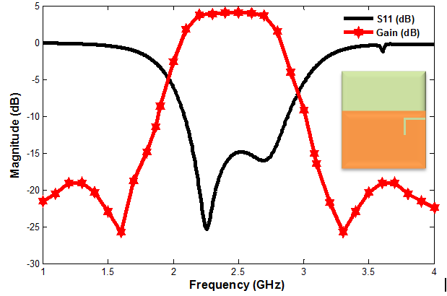
Figure 6. S₁₁-parameter and gain of the filtering antenna

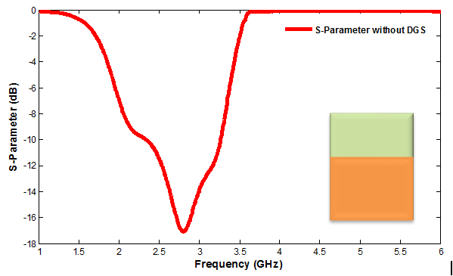
Figure 7. S₁₁-parameter of the filtering antenna without DGS

Etching the DGS in the ground plane of the filtering antenna disturbed the shield current distribution in a wave-guiding structure. This disturbance will change properties of the design such as the effective capacitance and effective inductance [24]. The feature of DGS is a slow-wave impact because the equivalent LC components that may decrease the design circuit size [25]. From Figures 6 and 7, can notice that the significant and obvious effect of the DGS on the overall performance of the filtering antenna response. Figure 8, shows the S₁₁-parameter of the filtering antenna without the Square Open Loop Resonator (SOLR).

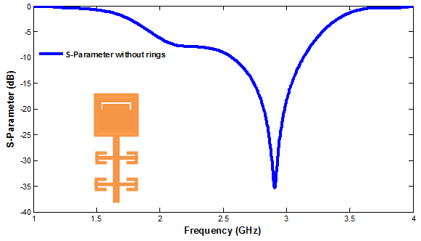
Figure 8. S₁₁-parameter of the filtering antenna without SOLR

Figure 9, shows the Far-field radiation pattern of the filtering antenna at a center frequency f_{o}= 2.412 GHz. The simulation results are obtained by using Computer Simulation Technology (CST) software.
The comparison graph of the reflection parameter for the three types of dielectric substrate material at a fixed substrate height h = 30.944 mils is shown in Figure 10. The effect of the dielectric substrate material on the design performance especially the center frequency and reflection parameter. Table 2 contains the comparison of some parameters of the three different dielectric substrate types for which the filtering antenna is designed and established in.
Figure 11, shows the comparison of the reflection parameter of the three different dielectric substrate materials, which the filtering antenna design is, established in, for different substrate heights. This comparison is a necessary issue to illustrate the effect of the dielectric substrate material type, and thickness. Table 3 contains the comparison of some of the important parameters involved in the design of the filtering antenna circuit on the three different dielectric substrate material types. The parameter comparison of these three types of the dielectric materials is stated in Table 3.

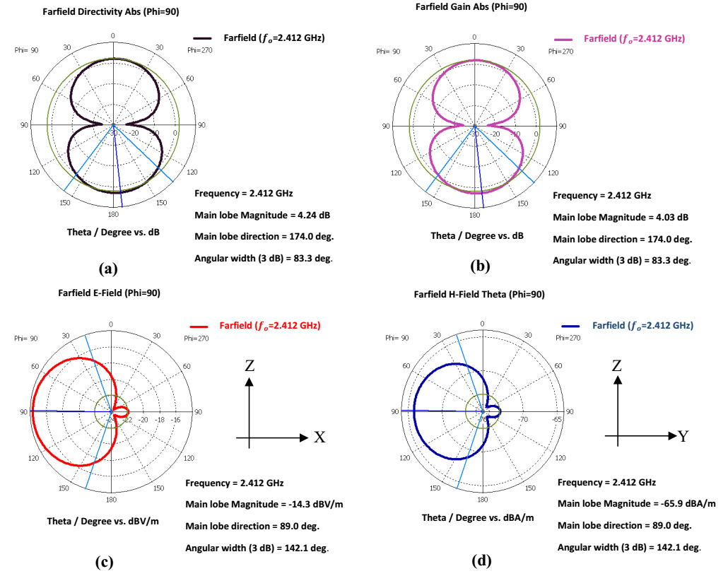

Figure 9. Far-field radiation pattern of the filtering antenna (a) Directivity (b) Gain (c) E-Field (d) H-Field.

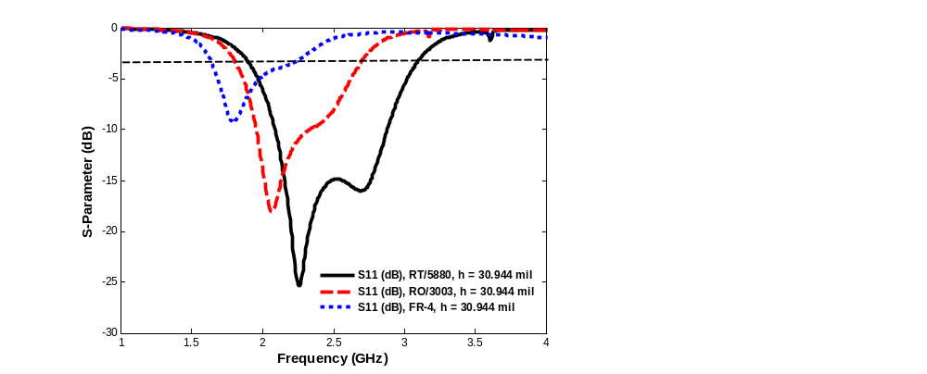
Figure 10. Comparison of S₁₁-parameter for the different dielectric substrate materials, h = 30.944 mil

Table 2. Comparison of some different parameters for the different dielectric substrate materials
Parameters | Dielectric Substrate type
Parameters | RT/ 5880 | RO3003 | FR-4
Center frequency (f_{o} GHz) | 2.412 | 2.202 | 1.924
Return loss RL (dB) | -15 | -12.065 | -6.0314
Maximum Gain (dB) | 4.03 | 2.43 | 1.18
BW (GHz) | 1.22 | 0.922 | 0.657
VSWR | 1.1937 | 1.58 | 2.2

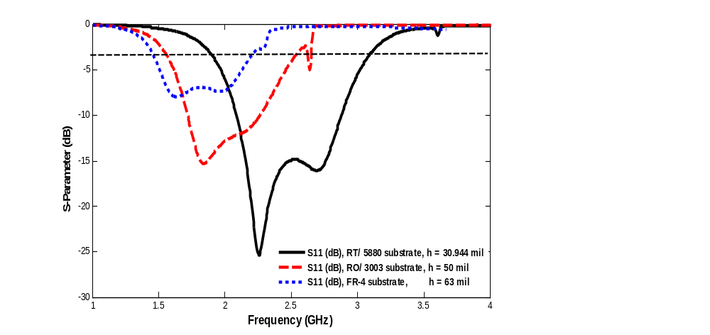
Figure 11. Comparison of S₁₁-parameter for the different dielectric substrate materials and different dielectric substrate heights

Table 3. The comparison of some of the important parameters involved in the design of the filtering antenna circuit on the three different dielectric substrate material types
Parameters | Dielectric Substrate type
Parameters | RT/ 5880 | RO3003 | FR-4
Center frequency (f_{o} GHz) | 2.412 | 2.3 | 2.049
Return loss RL (dB) | -15 | -13.063 | -7.04
Maximum Gain (dB) | 4.03 | 2.63 | 2.22
Substrate height (h)mils | 30.944 | 50 | 63
BW (GHz) | 1.22 | 1.3 | 1.059
VSWR | 1.1937 | 1.52 | 2.24

5. Conclusion
This article presents a microstrip filtering antenna design for WLAN applications in a center frequency f₀= 2.412 GHz. A microstrip-filtering antenna has designed and built on a three different dielectric substrate materials, which are RT/Duroid 5880, RO3003, and FR-4. These designs have done by using CST microwave studio suite software. The filtering antenna consists of four-pole bandpass filter integrated to monopole patch antenna. The comparison of the filtering antenna design, which is using the three different dielectric substrate materials at a fixed substrate height and different heights have done. The results obtained from each design indicate that the most suitable design for this application when established on RT/Duroid 5880 dielectric substrate material.

References
- HW Liu, BP Ren, S Li, XH Guan, P Wen, X Xiao. Y Peng. High-Temperature Superconducting Bandpass Filter Using Asymmetric Stepped-Impedance Resonators With Wide-Stopband Performance. IEEE Trans. Applied Superconductivity, 2015; 25(5):1-6.
- Y Tu, XR Guo, CH Wang, J Jin. An improved 860–960MHz fully integrated CMOS power amplifier designation for UHF RFID transmitter. International Journal of Electronics and Communications, 2013; 67(7): 574-577.
- YI Abdulraheem, A Abdullah, H Mohammed, R Abd-Alhameed, J. Noras. Design of Frequency-reconfigurable Multiband Compact Antenna using two PIN diodes for WLAN/WiMAX Applications. IET Microwaves, Antennas and Propagation, 2017; 11(8):1098-1105.
- Y Al-Yasir, R Abd-Alhameed, J Noras, A Abdulkhaleq. N Ojaroudi Parchin. Design of Very Compact Combline Band-Pass Filter for 5G Applications. Loughborough Antennas & Propagation Conference, Loughborough, UK, 2018; (1):1-4.
- YIA Al-Yasir, Y Tu, N Ojaroudi Parchin, I Elfergani, R Abd-Alhameed, J Rodriguez, J Noras. Mixed-coupling multi-function quint-wideband asymmetric stepped impedance resonator filter. Microw. and Opt. Tech. Lett, 2019; 61(5): 1181-1184.
- YIA Al-Yasir, Y Tu, N Ojaroudi Parchin, A Abdulkhaleq, J Kosha, A Ullah, R Abd-Alhameed, J Noras. New Multi-standard Dual-Wideband and Quad-Wideband Asymmetric Step Impedance Resonator Filters with Wide Stop Band Restriction. International Journal of RF and Microwave Computer-Aided Engineering, 2019; 29(8):1-17.
- W Chen, Y Zhao, Z Jun. Compact and Wide Upper-Stopband Triple-Mode Broadband Microstrip BPF. TELKOMNIKA Telecommunication, Computing, Electronics and Contro. 2012; 10(2): 353-358.
- ES Ahmed. Compact Dual-Band Parallel Coupled T-Shaped SIR Filter for WLAN Applications. TELKOMNIKA Telecommunication, Computing, Electronics and Contro. 2017; 15(4): 1677-1681.
- Mabrok M, Zahriladha Z, Masrukin E, Sutikno T, Othman AR, Nurhasniza E. Switchable Dual-band Bandpass Filter Based on Stepped Impedance Resonator with U-Shaped Defected Microstrip Structure for Wireless Applications. TELKOMNIKA Telecommunication Computing Electronics and Control. 2019; 17(2): 1032-1039.
- YIA Al-Yasir, Y Tu, MS Bakr, N Ojaroudi Parchin, AS Asharaa, WA Mshwat, RA Abd-Alhameed, JM Noras. Design of multi-standard single/tri/quint-wideband asymmetric stepped-impedance resonator filters with adjustable TZs," IET Microwaves, Antennas & Propagation. 2019; (1):1-9.
- A Taybi, A Tajmouati, J Zbitou, A Errkik, M Latrach, L Elabdellaoui L. A New Configuration of a High Output Voltage 2.45 GHz Rectifier for Wireless Power Transmission Applications. Telecommun Comput Electron Control J. 2018; 16(5): 1939–1946.
- YIA Al-Yasir, A Abdullah, N Ojaroudi Parchin, R Abd-Alhameed, J Noras. A new polarization-reconfigurable antenna for 5G applications. Electronics, 2018; 7(11):1-9.
- MHM Salleh, N Seman, R Dewan. The Investigation of Substrate’s Dielectric Properties for Improving the Performance of Witricity Devices. Applied Computational Electromagnetics Society Journal. 2017; 32(1): 24–30.
- B Yu, K Yang, C Sim, G Yang. A novel 28 GHz beam steering array for 5G mobile device with metallic casing application. IEEE Transactions on Antennas and Propagation. 2018; 66(1): 462–466.
- YIA Al-Yasir, N Ojaroudi Parchin, A Abdulkhaleq, R Abd-Alhameed, J Noras. Recent Progress in the Design of 4G/5G Reconfigurable Filters. Electronics, 2019; 8(1):1-17.
- A Khan, R Nema. Analysis of five different dielectric substrates on microstrip patch antenna. International journal of computer applications, 2012; (1):55.
- C-T Chuang, S-J Chung. A new compact filtering antenna using defected ground resonator. Microwave Conference Proceedings (APMC), 2010 Asia-Pacific, 2010; (1):1003-1006.
- J Coonrod. Choosing Circuit Materials for Millimeter Wave Applications. High Frequency Electronics, 2013; (1)22-30.
- D Leys. Best materials for 3–6 GHz design. Print. Circuit Des. Manuf., 2004; (1)34-39.
- A Khare, R Nema, P Gour, RK Thakur. New multiband E-shape microstrip patch antenna on RT DUROID 5880 substrate and RO4003 substrate for pervasive wireless communication. International Jounal of Computer Applications, 2010; (9): 0975-8887.
- SS Afrin, PR. Dev. Performance Analysis of Microstrip Patch Antenna for Ultra Wide Band Application. East West University; 2015.
- FK Szostak, P Słobodzian. Broadband Dielectric Measurement of PCB and Substrate Materials by Means of a Microstrip Line of Adjustable Width. IEEE Microwave and Wireless Components Letters, 2018; 1(1):945-947.
- K Kapusuz, S Lemey, H Rogier. Substrate-Independent Microwave Components in Substrate Integrated Waveguide Technology for High-Performance Smart Surfaces. IEEE Transactions on Microwave Theory and Techniques, 2018; 1(1):3036-3047.
- G Breed. An introduction to defected ground structures in microstrip circuits. High Frequency Electronics, 2008; 7:50-54.
- FS Mahmud, MS Razalli, HA Rahim, WF Hoon, MZ Ilyas. Parametric studies on effects of defected ground structure (DGS) for dual band bandstop microstrip filter. EPJ Web of Conferences, 2017; 1(1)1-5.

