Design and Analysis of Single layer QCA based 1- bit Comparators

Ziyad A. Altarawneh¹ and Mutaz Al-Tarawneh²

¹Department of Electrical Engineering, Mut’ah University, Jordan
²Department of Computer Engineering, Mut’ah University, Jordan

Article Info |  | ABSTRACT
Article history:  Received mm dd, yyyy  Revised mm dd, yyyy  Accepted mm dd, yyyy |  | Quantum dot-cellular automata (QCA) technology is emerging as a potential candidate for the design of nanometer-scale computational circuits. In digital logic circuits, the comparator is the basic building block for comparing two binary values. This paper presents the design and implementation of two 1-bit QCA based comparators. The proposed QCA implementations are compact, require only a single layer and are therefore less complex compared to recent reported designs. The QCADesigner tool has been used to confirm the functional validity of the proposed QCA structures. The simulation results of the proposed comparators have shown considerable improvement compared to current comparators in terms of cell count, area, cost and efficient complexity. In addition, the proposed 1-bit comparator structures achieved a 25.8 % and 54.5% reduction in the number of cell requirements when compared to the best comparator designs. Moreover, both of the proposed structures achieve low cost and efficient complexity values relative to the recently reported structures. Moreover, all of the proposed structures are dissipating extremely low energy. Thus, proposed QCA based comparators can be viable option for low power digital applications.
Keywords:
QCA technology
Low power
1-bit comparator
Single QCA layer

This is an open access article under the CC BY-SAlicense.

Corresponding Author:
Ziyad A. Altarawneh,
Department of Electrical Engineering,
Mut’ah University,
Alkarak, Jordan.
Email: zdtarawneh@mutah.edu.jo

- INTRODUCTION

CMOS scaling technology has been the key driving force behind the development of higher density and faster computing systems in the microelectronics industry [1]. In the last few decades, according to Moore’s law, the number of transistors per chip and the performance of the digital systems have increased exponentially. However, the increasing density of number of transistors in a chip caused an increased dissipation of power in the digital system. More integration levels and improved device performance also have increased the propensity to scale almost all of the parameters within the device structure, such as effective channel length, gate oxide thickness, junction depths, etc. Some of these parameters have, however, reached their physical limits [1-4] . As a result, alternatives to current materials and device structures need to be found in order to continue to device scaling. One of the promising alternative technologies is Quantum dot-cellular automata (QCA) technology, which has been considered as a potential solution for overcoming the physical difficulties in the existing CMOS technology due to its unique characteristics such as ultra-high speed, high packing density and reduced energy consumption [3, 5]. In QCA technology, the basic cell consists of four quantum dots; containing two electrons capable of tunneling between adjacent dots, the position of the electrons represents the logical state of the cell [4, 6]. Unlike traditional CMOS structures, the information is transmitted via the flow of electrical current from input to output. While, columbic interactions between adjacent cells enables the data transmission in QCA technology [4].
Various strategies for data transmission and computation are usually used to build logical circuits on the basis of a nano-scale QCA technology [4, 7]. However, as the QCA technology utilizes electrostatic repulsions to propagate the logic data, there is no existing guarantee so that the information will move to the desired direction. To ensure proper data flow in QCA based designs, QCA circuit clocking mechanism is introduced [8]. In fact, circuits based on QCA technologies are clocked in four-phases namely switch, hold, release and relax. The electric field caused by the clock signal is used to increase or decreases the tunneling barrier of quantum dots in the QCA cell. The electrons can be transferred from one dot to another inside the QCA cell, when the potential of the tunneling barrier is low. However, if the potential barrier is strong, the electrons are locked within the dots and the external electrical fields have little impact on the state of the cell. In order to control the transmission of information across adjacent cells in a QCA-based structure, four clocking zones are typically used with each clocking zone is shifted by 90° with its neighboring zones [9, 10].
In QCA technology, the inverter and the majority gate are the two basic building blocks used to achieve more logical functionality. AND and OR operations can be performed by either setting the '0' logic or the '1' logic to one of the inputs of the majority gate [4, 8, 11]. In order to allow a certain degree of design versatility in QCA technology, two types of wiring crossovers are usually used in the design of the QCA circuit, namely coplanar and multilayer crossovers. The coplanar crossing uses only one layer and uses both 45° and 90° cells so that they do not interfere with each other. However, the coplanar crossover has low immunity against structural defects and can fail during the processing of QCA-based structures [4, 7, 11]. On the other hand, multi-layer crossover uses a peculiar number of layers, usually three layers. The entire circuit is mainly constructed on the bottom layer while the crossover wires are located on the top and the middle layers to serve as a connection between the layers. Compared to coplanar based structures, the multilayer crossover consumes less area despite the increased manufacturing complexity [7].
In recent years, extensive research works have been proposed many computational QCA based circuits [12, 13], such as Arithmetic and Logic Unit (ALU) [12, 14, 15], counters [16-18], multipliers [19, 20], nano-sensor data processors [21], and full adders and substractors [22, 23]. Evidently, the diversity of QCA-based logic and memory architectures is incorporating QCA technology as an important candidate for a future computing paradigm. In this context, the comparator is a critical component in a variety of digital applications such as processors, microcontrollers, and digital communication systems [24-26]. It has the function of defining three states of two n-bit numbers, which may be provided in serial or parallel manner, and then comparing and providing three possible cases: equal, larger, or smaller than each other [24-27]. The authors of [28] proposed QCA implementation of 1-bit comparator using reversible Feynman QCA gates, the proposed structure was composed of 87 cells and it covers an area of 0.11 μm². In this paper, three Feynman QCA gates were used to achieved the desired outputs (A>B and A<B and A=B). Roy.et al [25] proposed two implementations of 1-bit comparator using the layered-T AND and OR gates. The number of cells requirement of the proposed designs was 40 and 37 QCA cells with occupational area of 0.032μm² and 0.028μm² respectively [25]. The proposed comparators also implemented with a fairly low-cost function. Furthermore, the fault-tolerance aspect of the 37-cell 1-bit comparator structure is also investigated. Moreover, Umira et al. [27] proposed a universal FNZ gate based 1-bit comparator. The proposed comparator uses 58 QCA cell with an area of 0.055μm² and a delay of 3 clock cycles. In addition, The authors of [29] have implemented a multilayer QCA-based comparator using a five-input majority gate. In this research work, a 1-bit comparator with a delay of three clock cycles is presented. Nevertheless, the proposed comparators are not achieving a significant improvement in cell count and area occupancy. Deng, et al. [30] introduced the XNOR gate-based implementation of multi-bit comparators. In this paper, a robust and efficient XNOR gate with very high reliability and low dissipation of power was firstly proposed. Thereafter, the authors used the proposed XNOR to implement multi-bit comparator circuits. The proposed comparators are multilayer and have achieved less complexity value. Recently, a coplanar 1-bit QCA comparator structure was proposed in [31]. The proposed coplanar QCA comparator was built on the basis of the basic QCA logic gates, including the majority, XNOR, and inverter gates. The implemented QCA based comparator reduces cell count, occupied area, latency, and cost compared to earlier other designs. More recently, Gao et al. [26] proposed a 1-bit QCA comparator using a single layer and 31 QCA cells with an occupational area of 0.04μm²; the proposed design consists of two AND gates, one OR gate and three inverters. The main benefit of this design is that it does not require any wiring crossover and only uses one layer of the QCA layout. In fact, there is considerable attention to the implementation of the high-performance comparator circuit using QCA technology utilizing small area and low power QCA based structures. Therefore, recent attempts have been made to improve the performance of comparator circuits which remain widely investigated and optimized [26, 30, 31]. In this paper, area efficient comparator structures are designed and implemented based on QCA technology. The evaluation of the functionality of the proposed circuits is carried out using the QCADesigner tool. Comprehensive comparisons have been made between the proposed comparators and the recently published designs, and the findings show that the presented designs have greatly reduced cell count, area requirements when compared with the best recent reported designs.
The remainder of the paper is organized as follows. Section 2 describes the proposed 1-bit comparator structures. Section 3 explores the functional validity of the proposed designs using the QCADesigner tool. In addition, performance evaluations and comparisons are made in this section. The conclusions are eventually drawn in Section 4.

- Proposed Comparator structures

Two area-efficient 1-bit comparator designs based on the QCA technology are successively proposed in this section. Figures 1 and 2 show the proposed structures of 1-bit comparators using single QCA layer. As shown, the comparator circuit compares two binary inputs (A, B) and determines whether one of input is identical, greater, or lower than the other as demonstrated from the truth table of 1 bit comparator in Table 1 [26]. Therefore, three outputs are produced: F_{A=B}, F_{A>B} and F_{A<B}. The algebraic expressions describing the behavior of 1-bit comparator are given as:

$F_{A=B}=\overline{A⊕B}$
$F_{A>B}=A .\overline{B }$ (1)
$F_{A<B}=\overline{A }.B$

Table 1. Truth table of 1-bit comparator
A | B | F_{A=B} | F_{A>B} | F_{A<B}
0 | 0 | 1 | 0 | 0
0 | 1 | 0 | 0 | 1
1 | 0 | 0 | 1 | 0
1 | 1 | 1 | 0 | 0

The first implementation of the proposed single layer 1-bit comparator (Design A) is shown in figure 1, where A, B are two inputs and the output cells are depicted as F_{A<B}, F_{A>B} and F_{A=B}. As shown, the proposed structure is implemented using 3-clock zones, mainly to influence the direction of the data flow and also to propagate the computational results to the output cells. The proposed structure includes two 3-input majority gates with the first two majority gates to obtain outputs (F_{A>B}) and (F_{A<B}). These outputs are used as inputs for the third-majority gate to produce the output (F_{A=B}). The proposed 1-bit comparator design uses only 23 cells without the need for any wiring crossover. Moreover, it can be noticed that the outputs (F_{A>B}) and (F_{A<B}) are accomplished using two clock zones (i.e. clock zone 0 and 1), while the output (F_{A=B}) is produced using three clock zones (i.e. clock zone 0, 1 and 2).
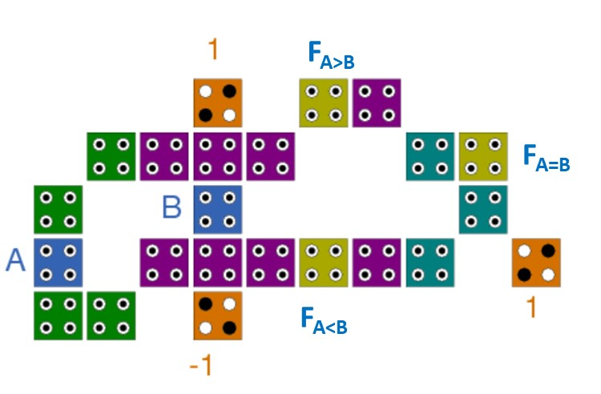
Figure 1. The first proposed QCA implementation of 1-bit comparator-Design A

The second implementation of the proposed 1-bit single-layer comparator circuit (Design B) is shown in figure 2. The proposed 1-bit comparator is compact and only requires 14 QCA cells with an area of 0.02μm². in addition, it does not require any type of crossover. In this design, the outputs (F_{A<B}, F_{A>B} and F_{A=B}) are obtained by utilizing two clock zones (i.e. Clock zone 0 and 1). The achieved improvement of the second proposed design as compared to the first proposed counterpart in terms of cell count is found to be 64.3%. Furthermore, the second proposed structure has lower output delay as it clocked using two clock zones.
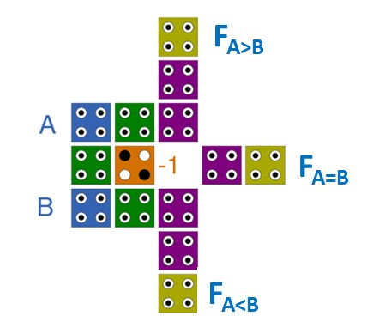
Figure 2. The second proposed QCA implementation of 1-bit comparator-Design B

- RESULTS AND DISCUSSIONS

The QCADesigner-2.0.3 simulation tool [32] was employed to evaluate the functionality of proposed 1-bit comparator structures and also to determine their structural costs in terms of their number of cells , the area occupied and the delay between inputs and outputs. In this study, the simulation parameters are set up as presented in Table 2.

Table 2. Simulation parameters used in QCADesigner tool
Parameter | Value
QCA cell width | 18 nm
Cell height | 18 nm
Diameter of the quantum dot | 5nm
Number of samples | 12800
Number of iterations per sample | 10000
Radius of effect | 65 nm
Layer separation | 11.5 nm

Figure 3 shows the simulation results of the first proposed structure 1-bit comparator (Design A). As shown, the results confirm the functional validity of the proposed structure as compared with the logical values shown in Table 1. As can be seen from figure 3, when the input (A) is equal to input (B), only the corresponding output (F_{A=B}) will be high. Whereas if the input (A) is greater than the input (B), only the output labeled with (F_{A>B}) will be at a high logic level. Alternatively, the output labeled with (F_{A<B}) is high once the input (A) is below the input (B). Moreover, it can be noticed that the outputs (F_{A>B}) and (F_{A<B}) are delayed by 0.5 clock cycle from the inputs, while the output (F_{A=B}) is delayed by 0.75 clock cycle.
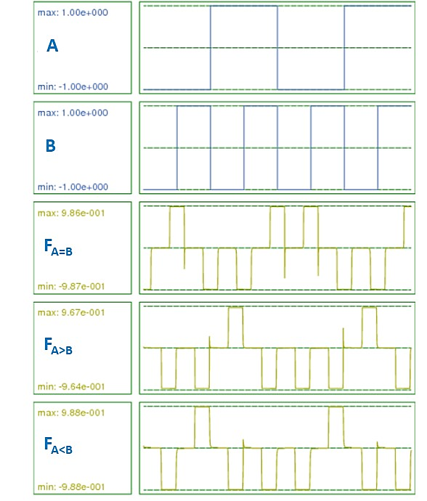
Figure 3. Simulation result of the first proposed QCA based 1-bit comparator (Design A)

The simulation result for the second implementation of the proposed 1-bit comparator (Design B) is shown in figure 4. Apparently, the proposed design achieves the intended comparison functionality. In addition, all of outputs in this structure are obtained after a delay of 0.5 clock cycle from the input signals. This means that the second proposed structure is 33% faster than the first proposed structure.
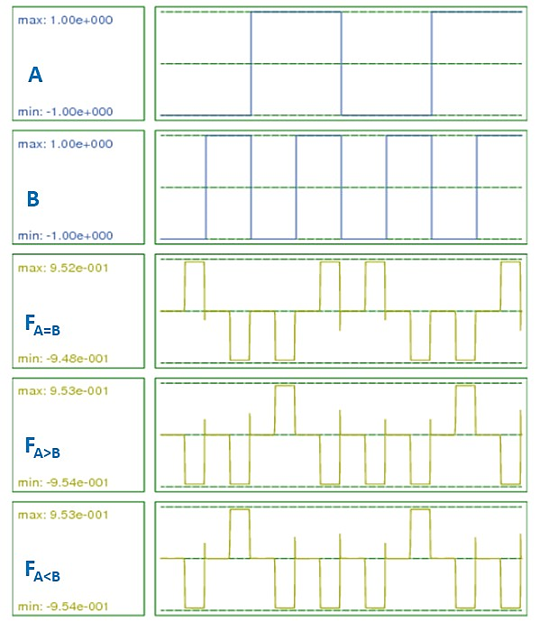
Figure 4. Simulation result of the second proposed QCA based 1-bit comparator (Design B)

Additionally, Figure 5 compares the prposed designs in terms of cell count (complexity) and occupational area. As shown, the proposed design (B) significantly reduces the number of QCA cells and occupational area requrements as compared with the prposed design (A). The achieved improvement in cell count and occupational area have reached 39% and 33%, respectively.
Figure 5. Comparisons of (a) cell count and (b) area of the proposed comparator structures

Moreover, the QCADesigner-E tool [33] has been used to estimate the energy dissipation of the proposed QCA-based structures. Figure 6 presents the total energy dissipation and the average energy dissipation per clock of the proposed structures. It can be seen that all of the proposed designs have low total and average energy dissipation levels. As compared to the first proposed design (Design A), the second proposed design (Design B) has lower total and average energy dissipation values. The improvement achieved is found to be 30.5% and 30.55% respectively in total energy dissipation and average energy. This is primarily due to the decreased number of cells required for such a design to be implemented.
Figure 6. Comparisons of (a) total energy dissipation and (b) average energy dissipation per clock cycle of the proposed comparator structures

Moreover, key comparison factors in designing and evaluating QCA based structures are cost and efficient complexity. In fact, the cost value depends on the area of QCA structure in µm² and the delay between the input and output per clock cycle which is given as [31, 34].
$Cost=Area.{Delay}^{2}$ (3)
While the Efficient Complexity (EC) was determined using the following equation [30]: $Efficient Complexity=Cell count.{Area}^{1/n}$ (4)
where n is the number of QCA layers.

Figure 6 show comparison of the prposed designs in terms of cost and efficient complexity values, as shown, the proposed design (B) has lower cost and efficient complexity values when compared with its counterpart. The achieved reductions in both values have reached approximitly 70%.

Figure 6. Comparisons of (a) cost and (b) efficient complexity values for the proposed comparator structures.

Table 3 compares the proposed 1-bit comparator designs with recent QCA-based designs. The comparison parameters are cell count, area, delay, crossover type, cost and Efficient Complexity (EC) values. It can be seen from table 3 that the proposed 1-bit comparator structures (Design A and B) outperform the recently reported designs. In addition, the proposed designs have achieved a reduction of 25.8% and 54.5% respectively in the number of cell requirements relative to the most recent structure in [26]. Moreover, the proposed designs require less occupational area as compared with the best reported design. The achieved reduction in the efficient complexity (EC) value has reached up to 26% as compared with the best reported design [26]. In addition, compared to the first proposed structure (Design A), it can be observed that the area occupied of the design presented in [25] is smaller. This reduction in area, however, was due to the increased number of QCA layers (i.e. multilayers), and not primarily from the logic design, which is directly reflected in the high value of efficient complexity (EC) of such structure. Moreover, in contrast to the first proposed design (Design A), the structure proposed in [31] has a similar occupational area. This design, however, is based on a coplanar crossover that is susceptible to failure and may have major issues with reliability during manufacturing of such type of QCA based circuits [4, 7, 11]. Moreover, the second proposed design (Design B) outperforms all recent reported designs in terms of area, cell count. The achieved reductions in cell count and area have reached up to 54.5% and 75% respectively when compared to the most recent comparator design in [26]. Furthermore, the cost and efficient complexity (EC) values are reduced by 78% and 77.4% relative to that in [26]. It is worth noting that the proposed designs have been implemented using a single QCA layer without requiring any wiring crossover, which effectively reduces the complexity during manufacturing. Finally, the proposed structures give alternative 1-bit comparator designs with an efficient occupational area, cell count without the need of multilayer and coplanar crossover wiring techniques.

Table 3. Comparisons between the proposed comparator and recent designs
Reference | Cell count | Area (μm²) | Time delay (clock cycle) | Crossover | Cost | Efficient Complexity
[28] | 87 | 0.11 | 0.5 | Coplanar | 0.0275 | 9.57
[31] | 38 | 0.03 | 0.5 | Coplanar | 0.0075 | 1.14
[30] | 42 | 0.05 | 0.75 | Not required | 0.0281 | 2.1
[25] | 37 | 0.028 | 1 | Multilayer | 0.028 | 11.2
[27] | 58 | 0.055 | 0.75 | Not required | 0.031 | 3.19
[29] | 100 | 0.11 | 0.75 | Multilayer | 0.0618 | 47.9
[26] | 31 | 0.04 | 0.75 | Not required | 0.0225 | 1.24
Design A | 23 | 0.03 | 0.75 | Not required | 0.0169 | 0.69
Design B | 14 | 0.02 | 0.5 | Not required | 0.005 | 0.28

- CONCLUSION

In this paper, two different 1-bit comparator QCA-based structures were introduced and thoroughly evaluated. The logical functionality of the proposed comparators has been verified by the QCADesigner tool and energy dissipation computations have been performed using QCADesigner-E. Performance comparisons with the previously reported designs in terms of area, cell count, delay, cost, and efficient complexity were also included. The simulation results showed that the required cells are 23 and 14 cells in the proposed 1-bit comparator designs. The proposed 1-bit comparator structures have achieved reduction in the number of cell requirements 25.8 % and 54.5% respectively when compared to the most recent comparator designs. Furthermore, the values of efficient complexity parameter of the proposed structures have been reduced by 44.3% and 77.4% respectively as compared with the best of recent reported design [26] . Another important aspect of the proposed designs is that they do not require any wiring crossover. In future, the proposed QCA designs can be expanded to n-bit comparators so that many arithmetical circuits are efficiently constructed.

REFERENCES

[1] A. Razavieh, P. Zeitzoff, and E. J. Nowak, "Challenges and Limitations of CMOS Scaling for FinFET and Beyond Architectures," IEEE Transactions on Nanotechnology, vol. 18, pp. 999-1004, 2019.
[2] N. Z. Haron and S. Hamdioui, "Why is CMOS scaling coming to an END?," in 2008 3rd International Design and Test Workshop, 2008, pp. 98-103.
[3] C. S. Lent and P. D. Tougaw, "A device architecture for computing with quantum dots," Proceedings of the IEEE, vol. 85, pp. 541-557, 1997.
[4] F. Ahmad, M. U. John, M. B. Khosroshahy, S. Sarmadi, G. M. Bhat, Z. A. Peer, et al., "Performance evaluation of an ultra-high speed adder based on quantum-dot cellular automata," International Journal of Information Technology, vol. 11, pp. 467-478, 2019/09/01 2019.
[5] S. K. Anumula and X. Xiong, "Design and Simulation of 4-bit QCA BCD Full-adder," in 2019 IEEE Long Island Systems, Applications and Technology Conference (LISAT), 2019, pp. 1-6.
[6] J. F. Chaves, M. A. Ribeiro, L. M. Silva, L. M. B. C. de Assis, M. S. Torres, and O. P. Vilela Neto, "Energy efficient QCA circuits design: simulating and analyzing partially reversible pipelines," Journal of Computational Electronics, vol. 17, pp. 479-489, 2018/03/01 2018.
[7] W. Liu, L. Lu, M. O. Neill, and E. E. Swartzlander, "Design rules for Quantum-dot Cellular Automata," in 2011 IEEE International Symposium of Circuits and Systems (ISCAS), 2011, pp. 2361-2364.
[8] S. Aralikatti, "QCA Designer: A simulation and Design Layout Tool for QCA based Nano Domain Computing Architectures," in 2020 Second International Conference on Inventive Research in Computing Applications (ICIRCA), 2020, pp. 1042-1046.
[9] T. N. Sasamal, A. K. Singh, and A. Mohan, "Clocking Schemes for QCA," in Quantum-Dot Cellular Automata Based Digital Logic Circuits: A Design Perspective, T. N. Sasamal, A. K. Singh, and A. Mohan, Eds., ed Singapore: Springer Singapore, 2020, pp. 139-145.
[10] H. M. H. Babu, "Quantum-dot cellular automata," in Quantum Computing, ed: IOP Publishing, 2020, pp. 18-1-18-10.
[11] K. Walus and G. A. Jullien, "Design Tools for an Emerging SoC Technology: Quantum-Dot Cellular Automata," Proceedings of the IEEE, vol. 94, pp. 1225-1244, 2006.
[12] S. Babaie, A. Sadoghifar, and A. N. Bahar, "Design of an Efficient Multilayer Arithmetic Logic Unit in Quantum-Dot Cellular Automata (QCA)," IEEE Transactions on Circuits and Systems II: Express Briefs, vol. 66, pp. 963-967, 2019.
[13] V. S. Kalogeiton, D. P. Papadopoulos, O. Liolis, V. A. Mardiris, G. C. Sirakoulis, and I. G. Karafyllidis, "Programmable Crossbar Quantum-Dot Cellular Automata Circuits," IEEE Transactions on Computer-Aided Design of Integrated Circuits and Systems, vol. 36, pp. 1367-1380, 2017.
[14] V. Kanimozhi and R. Gowri Shankar, "Design and implementation of Arithmetic Logic Unit (ALU) using modified novel bit adder in QCA," in 2015 International Conference on Innovations in Information, Embedded and Communication Systems (ICIIECS), 2015, pp. 1-6.
[15] M. R. Gadim and N. J. Navimipour, "Quantum-Dot Cellular Automata in Designing the Arithmetic and Logic Unit: Systematic Literature Review, Classification and Current Trends," Journal of Circuits, Systems and Computers, vol. 27, p. 1830005, 2018/09/01 2018.
[16] M. Abdullah-Al-Shafi, A. N. Bahar, M. A. Habib, M. M. R. Bhuiyan, F. Ahmad, P. Z. Ahmad, et al., "Designing single layer counter in quantum-dot cellular automata with energy dissipation analysis," Ain Shams Engineering Journal, vol. 9, pp. 2641-2648, 2018/12/01/ 2018.
[17] K. S. Bhavani and V. Alinvinisha, "Utilization of QCA based T flip flop to design counters," in 2015 International Conference on Innovations in Information, Embedded and Communication Systems (ICIIECS), 2015, pp. 1-6.
[18] M. Raj and L. Gopalakrishnan, "Novel Reliable QCA Subtractor Designs using Clock zone based Crossover," in 2019 3rd International conference on Electronics, Communication and Aerospace Technology (ICECA), 2019, pp. 497-501.
[19] B. S. Premananda, U. K. Bhargav, and K. S. Vineeth, "Design and Analysis of Compact QCA Based 4-Bit Serial-Parallel Multiplier," in 2018 International Conference on Electrical, Electronics, Communication, Computer, and Optimization Techniques (ICEECCOT), 2018, pp. 1014-1018.
[20] T. N. Sasamal and A. Kumar, "Design of adder and binary multiplier in QCA using coplanar technique," in 2017 International Conference on Intelligent Computing and Control (I2C2), 2017, pp. 1-6.
[21] F. Yao, M. S. Zein-Sabatto, G. Shao, M. Bodruzzaman, and M. Malkani, "Nanosensor Data Processor in Quantum-Dot Cellular Automata," Journal of Nanotechnology, vol. 2014, p. 259869, 2014/02/09 2014.
[22] D. Abedi, G. Jaberipur, and M. Sangsefidi, "Coplanar Full Adder in Quantum-Dot Cellular Automata via Clock-Zone-Based Crossover," IEEE Transactions on Nanotechnology, vol. 14, pp. 497-504, 2015.
[23] M. Raj, R. S. Kumaresan, and L. Gopalakrishnan, "High Speed Controllable Inverter for Adder-Subtractor in QCA," in 2019 10th International Conference on Computing, Communication and Networking Technologies (ICCCNT), 2019, pp. 1-5.
[24] D. Ajitha, K. V. Ramanaiah, and V. Sumalatha, "A novel design of cascading serial bit-stream magnitude comparator using QCA," in 2014 International Conference on Advances in Electronics Computers and Communications, 2014, pp. 1-6.
[25] S. S. Roy, C. Mukherjee, S. Panda, A. K. Mukhopadhyay, and B. Maji, "Layered T comparator design using quantum-dot cellular automata," in 2017 Devices for Integrated Circuit (DevIC), 2017, pp. 90-94.
[26] M. Gao, J. Wang, S. Fang, J. Nan, and L. Daming, "A New Nano Design for Implementation of a Digital Comparator Based on Quantum-Dot Cellular Automata," International Journal of Theoretical Physics, 2020/05/26 2020.
[27] S. Umira, R. Qadri, Z. A. Bangi, and M. T. Banday, "A Novel Comparator-A Cryptographic Design in Quantum Dot Cellular Automata," in 2018 International Conference on Sustainable Energy, Electronics, and Computing Systems (SEEMS), 2018, pp. 1-10.
[28] R. Akter, N. Islam, and S. Waheed, "Implementation of Reversible Logic Gate in Quantum Dot Cellular Automata," International Journal of Computer Applications, vol. 109, pp. 41-44, 2015.
[29] L. Jun-wen and X. Yin-shui, "A Novel Design of Quantum-Dots Cellular Automata Comparator Using Five-Input Majority Gate," in 2018 14th IEEE International Conference on Solid-State and Integrated Circuit Technology (ICSICT), 2018, pp. 1-3.
[30] F. Deng, G. Xie, Y. Zhang, F. Peng, and H. Lv, "A novel design and analysis of comparator with XNOR gate for QCA," Microprocessors and Microsystems, vol. 55, pp. 131-135, 2017/11/01/ 2017.
[31] A. R. Ahmadreza Shiri, Hamid Mahmoodian, "Design of Efficient Coplanar Circuit in QCA Technology " FACTA UNIVERSITATIS, Series: Electronics and Energetics, vol. 32, pp. 119-128, 2019.
[32] K. Walus, T. J. Dysart, G. A. Jullien, and R. A. Budiman, "QCADesigner: a rapid design and Simulation tool for quantum-dot cellular automata," IEEE Transactions on Nanotechnology, vol. 3, pp. 26-31, 2004.
[33] F. S. Torres, R. Wille, P. Niemann, and R. Drechsler, "An Energy-Aware Model for the Logic Synthesis of Quantum-Dot Cellular Automata," IEEE Transactions on Computer-Aided Design of Integrated Circuits and Systems, vol. 37, pp. 3031-3041, 2018.
[34] H. Rashidi and A. Rezai, "High-performance full adder architecture in quantum-dot cellular automata," The Journal of Engineering, vol. 2017, pp. 394-402, 2017.

BIOGRAPHIES OF AUTHORS

 | Ziyad A. Al Tarawneh is an associate professor in the Electrical Engineering Department of Mut’ah University. He received his B.Sc. degree in electrical engineering from Damascus University, Syria, in 2004. He has received his M.Sc. and Ph.D. degrees in Microelectronics Engineering from Newcastle University, United Kingdom, in 2007 and 2011 respectively. His current research interests include digital electronics, circuit reliability, asynchronous circuit design and low-power VLSI design. He published many journal papers and contributed to several international conferences.
 | Mutaz Al-Tarawneh is an associate professor of Computer Engineering at Mutah University. He has obtained his PhD in Computer Engineering from Southern Illinois University Carbondale, USA in 2010. His current research interests include Computer Architecture, Cloud Computing and Machine Learning applications.

